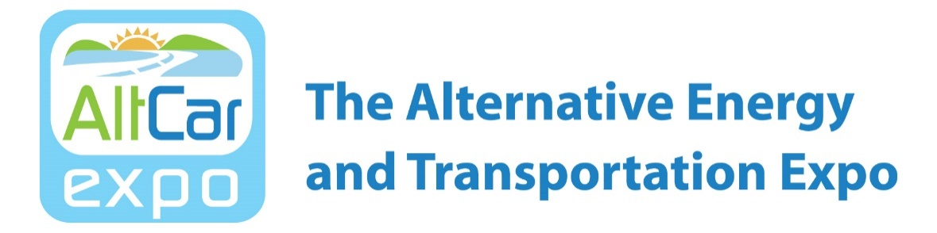

FOR IMMEDIATE RELEASE CONTACT: Trina Kaye – The Trina Kaye Organization
MEDIA ALERT TrinaKaye@tkopr.com / (310) 915-0970

AltCar Expo Teams up with Brown Administration to Launch Biggest Ride & Drive of Alternative Fuel Vehicles Ever Assembled at State Capitol on May 9
The Public is Invited to Join Administration Officials and Legislators to Check Out Clean, Cool Cars and Trucks Featuring Sacramento Debut of 200-Mile Range
All-Electric Chevrolet Bolt

Sacramento, CA - AltCar Expo will present the largest array of alternative fuel vehicles ever assembled at the State Capitol and will host a special Ride & Drive on Monday, May 9, 2016 from 11 a.m. until 2 p.m. Members of the Brown administration will kick off the event with a press availability at 10:30 a.m. AltCar Expo is the nation’s leading forum for alternative fuel vehicle ride and drive, public education and demonstration of the latest technology vehicles. The event will take place on the west steps of the State Capitol and is free and open to the public, fleet managers and policy makers.

Leaders from the Brown administration and Legislature will be on hand to show their support for alternative fuel and clean air initiatives and to learn about opportunities to help accelerate the use of alternative fuel vehicles in the communities they represent. Participating in AltCar aligns with Governor Brown’s goals of reducing vehicle emissions and combating climate change. Several state agencies are leading by example by driving electric vehicles, plug-in hybrids, and other zero-emission vehicles available on state contracts.
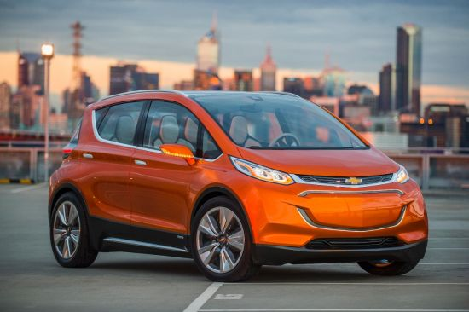
The vehicles that will be available for test drives include: electric, hybrid electric, hydrogen, natural gas, propane and renewable diesel vehicles. Vehicle specialists and electric vehicle infrastructure experts will be on site to answer fleet and consumer questions.
The 2017 Chevrolet Bolt EV will make its Sacramento debut at the AltCar Expo. The Bolt EV, which will go into production by the end of 2016, will offer more than 200 miles of range on a full charge and cost about $30,000 after the federal tax credit. It features advanced connectivity technologies designed to enhance and personalize the driving experience. The Bolt EV is capable of using the latest mobile app technology to enable car sharing, advanced GPS routing and gamification, all designed to enhance the ownership experience now and into the future.
Other cars participating in the Ride & Drive include:
Nissan LEAF
Chevrolet Volt
Toyota Mirai
Toyota Prius
Smart EV
Audi A3 Sportback e-tron
Volkswagen e-Golf

Government Operations Secretary Marybel Batjer and Department of General Services Director Daniel C. Kim will be participating in the Ride & Drive along with members of the state Assembly and Senate. In addition, at noon, Sacramento County will get the keys to their new Toyota Mirai as they begin integrating low-emission vehicles into their county fleet.

The Sacramento AltCar Ride & Drive Expo is sponsored by the California Department of General Services, Sacramento Clean Cities Coalition, and the Sacramento Air Quality Management District. Featured partners include GM, Audi, Volkswagen, Nissan, Toyota, the Plug-in Electric Vehicle Collaborative and CarbonBlu.

For more information on attending or exhibiting, contact Platia Productions at (310) 390-2930 or Platia@earthlink.net. For more information on the event, visit www.AltCarExpoSac.com.

For media inquiries contact Trina Kaye – The Trina Kaye Organization, (310) 915-0970 or TrinaKaye@tkopr.com.

